PROJECT62:4 GRANT
PROJECT EVALUATION TOOL

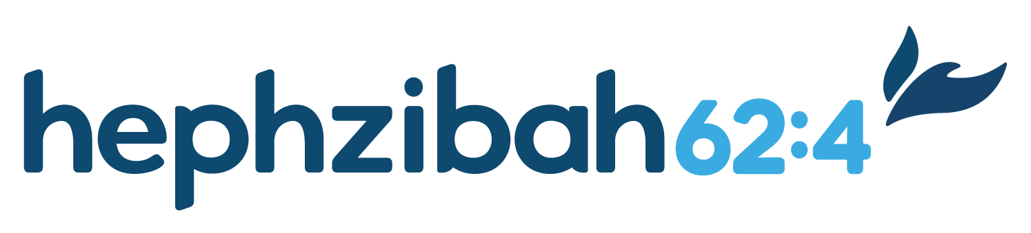
Thank you for your investment in the lives of the vulnerable children in your community! We are honored to partner with you and celebrate the effort you put into planning and executing your Project. This is your chance to tell us how it went, what you learned, and the impact you are witnessing in your community. Don’t worry if your project didn’t go perfectly or clearly match your hoped-for outcome. We are thankful that you stepped out in obedience, and we trust God’s timing and plan!
Please submit to info@hephzibah.org by the date you indicated in your plan along with photos of your project. Keep in mind these photography and privacy protection guidelines and ask agencies for additional guidelines regarding children in foster care.
Project Name:

Project Description:

Project Leader:

Project Team Members:

Number of people served:

Demographic information of people served:

Original problem identified:

Original desired outcome:

How successful was your project on a scale from 1-10:

Why?

What went well?

What was a highlight?

What didn’t go so well and how could this be improved next time?

What did you learn about project planning and implementation?

What did you learn about those you served?

What did you learn about your community in general?

What did you learn about yourself/your team/your church?

What did you learn about Prayer/God/Jesus/Holy Spirit?

Could this project be turned into a ministry? If so, how? If not, what’s missing?

What advice would you give to someone planning a similar project?

How helpful was the Project62:4 Grant on a scale from 1-10?

Would you recommend the Project62:4 grant to others?

Is there anything you would change about our application, our planning template, or another part of our grant process?

Considering all the above, please provide at least one short testimony to inspire others! How did God use this project to impact either those serving or those being served?

Additional comments:

Thank you so much for taking the time to answer these questions! We hope that you have learned valuable insights and that this will be the first of many more projects, or perhaps the start of a new ministry at your church. Stay connected to Hephzibah62:4 to see other grant and equipping opportunities available.

